**MODULE TITLE: Big Data Visulisation**

**Code: COS7046-B**

**Level M**

**Academic Year: 2022/23 Semester 1**

**Coursework 1**

**Analysis and Visualisation of a Dataset**

**Aim**

To produce a piece of analysis along with a visualisation and write a research report for a chosen method of visualisation on a chosen dataset.

**Assessment Specification**

For this coursework, you are required to produce a document (1500 words) on a piece of research you have undertaken in order to describe a method of analysis and visualisation for a dataset of your choice. You can create your own dataset or use a publicly available dataset. For this coursework, you should pose an analysis question on the dataset you have chosen, propose a method of analysis and visualise the results of your analysis in order to answer your question. Your report should address the particular data analysis and visualisation technique(s) you have used along with a discussion on the strengths and weaknesses of using such technique(s).

For example, the table below shows a small dataset for the observed oxygen levels in the flue gas, when coal undergoes combustion in a furnace.

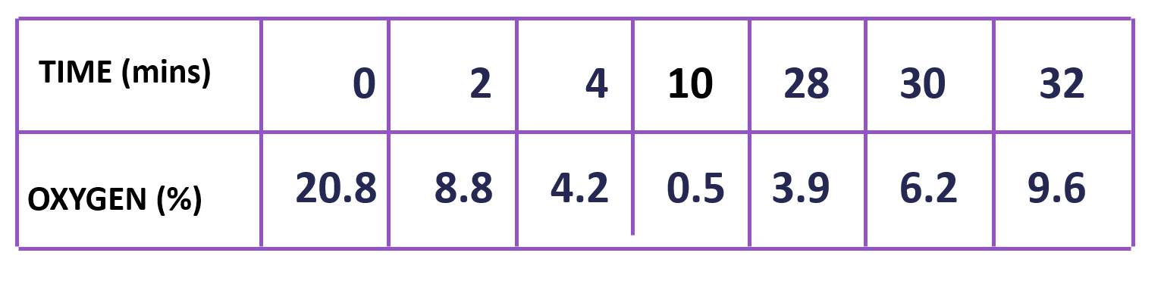

Linear interpolation can be performed and a continuous line graph can be drawn using Matlab to gain an understanding of the relationship between the oxygen level over time. Observations from the line graph can help to critically analyse the advantages and disadvantages of using simple linear interpolation techniques for analysis and visualisation of such a dataset.

**Effort required**

The coursework is worth 50% of the module marks. Students are expected to demonstrate good effort in processing the data, developing meaningful visualisations and writing up their reports. The coursework is worth 50% of the marks for this 20-credit module. A 20-credit module is nominally 200 hours of your time, some of which is spent in lectures, labs and private study. You should expect to be spending around 70 hours on this coursework.

**Deadline for submission of report**

The report must be submitted through Canvas before **4.00 pm Friday 25th Nov 2022**

Late submissions (without acceptable extenuating circumstances) will receive a mark of *zero*.

**Report structure**

You report (about 1500 words) should contain the information listed below.

* **Cover Page**: Title, author, affiliation of the author, date, and abstract
* **Introduction**: A rough overview of the space weather challenge you are tackling and its importance, frequently formulated to attract the reader's interest to the report.
* **Background**: Here you are required to have an overview about visualisation technologies and platforms. Then, you can describe relevant approaches and systems, or you can introduce basic concepts that are necessary for understanding the later material.
* **Main Part**: This section contains an explanation, demonstration, description of the system architecture, or some interesting implementation techniques. Discussion of some targeted methods for solving the space weather visualisation problem will be mostly encouraged.
* **Analysis and Discussions**: You need to present your findings and discuss, analyse, evaluate and/or criticise what you implemented and described in the previous part.
* **Bibliography and Citations**: It is imperative that whenever you make reference to a fact of some sort, you cite an authoritative source for that fact; most frequently, these sources will be scientific articles.

**Marking Scheme:**

|  |  |  |  |  |  |  |
| --- | --- | --- | --- | --- | --- | --- |
| **Criteria** | **>80%** | **70-80%** | **60-70%** | **50-60%** | **40-50%** | **<40%** |
| **Presentation of the report (25%)** | Report fully documents a working system. Report includes publishable, novel material. | Fully adheres to student guidelines. Lack of spelling and grammatical errors. Very good use of appropriate language. Excellent structure and organisation. | Mainly adheres to student guidelines. Minor spelling and grammatical errors. Good use of appropriate language. Well-structured with logical organisation | Some adherence to student guidelines. Some spelling and grammatical errors. Inconsistent use of appropriate language. Organisation and progression evident. | Little adherence to student guidelines. Many spelling and grammatical errors. Minimal use of appropriate language. Inadequate attention to structure and organisation | Does not adhere to student guidelines. Major deficiencies in spelling and grammar. Lack of appropriate language. A disorganised report with lack of evident structure. |
| **Description and achievement (25%)** | Novel or innovative solution to complex real-world problem. Exceptional amount of high quality work. Comprehensive testing completed, critically reviewed and results incorporated into product. | Problem is meaningful, innovative challenging and complex. Problem explicitly stated with precise explanation of all research objectives. Fully tested (or in theoretical submissions – excellent analysis and recommendations). | A relevant and original topic which is effectively translated into project aims and objectives which are clearly stated. Well tested system or prototype (or in theoretical submissions – good analysis and recommendations). | Appropriate problem area chosen. Objectives outlines with the main areas of investigation identified. Some evidence of adequate testing (or in theoretical submissions – Some analysis and recommendations). | Limited topic choice with the problem area poorly defined. Objectives vague or insufficient. Very limited testing (or in theoretical submissions – Very limited analysis and recommendations).  . | Simple or unoriginal problem showing lack of imagination (relies on title to direct project). No or inadequate testing (or in theoretical submissions – no analysis and recommendations) |
| **The demonstration of development capability (25%)** | Signs of professionally developed specification and system. System/prototype at sellable level. Ability to fully answer all questions with evidence of excellent understanding. Specification effectively interpreted with signs of original thinking. | Fully developed specification. System / prototype fully developed. Ability to fully answer all questions with evidence of excellent understanding. Specification effectively interpreted with signs of original thinking. | Specification developed mostly in accordance with research purpose. System / prototype developed mostly in accordance with research purpose. Ability to answer all questions with good evidence of understanding. Specification interpreted with consistent focus. | Partial in-depth development of initial specification. Appropriate development of system or prototype. Ability to answer most questions with evidence of understanding. A fair interpretation of the specification. | Limited development of initial specification. Limited development of system or prototype. Ability to answer questions with limited understanding. Limited interpretation of the specification. | No specification provided. System/prototype has very limited functionality. An inability to answer any questions. No reference to a specification and no focus.  . |
| **Quality of work and understanding (25%)** | Research findings break new ground. | Wide range of material. Excellent evidence of critical evaluation and original thinking. Substantial number of appropriate references. Evaluation and recommendations fully and appropriately reviewed and presented. Excellent link to implementation. Research findings fully consider broader issues. | Focus on key areas using relevant sources. Evidence of critical evaluation. Wide range of references with a varied bibliography. Clear evaluation & recommendations identifying key issues. Clear link to implementation. Research findings apparent with some consideration of broader issues. | Adequate information survey with some evidence of critical evaluation. Appropriate range of references. Good bibliography. Evaluation and recommendations identify some key issues. Link to implementation apparent. Research findings lack consideration of broader issues. | Limited sources of information used. Limited range of references. Limited bibliography. Limited evaluation and recommendations and limited ability to show the link to implementation. Lacking clarification of research findings. | Review of existing literature not evident. No references provided with limited or omitted bibliography. No evaluation or recommendations and inability to show the link to implementation. Conclusions do not link to research findings. |

**Feedback**

Feedback will be given via an assignment feedback sheet. Marks will be returned within 2 weeks of submission.

You should make yourself aware of the plagiarism policies of the University.